Items in the Lab, Inventory (Songhai Centre, Porto-Novo)

(Note that many of the numbers are generalized and not every single item was counted or included. Some items that are noted as glass may be Pyrex)

- 294 New large pipet tips (Not sure of actual name)
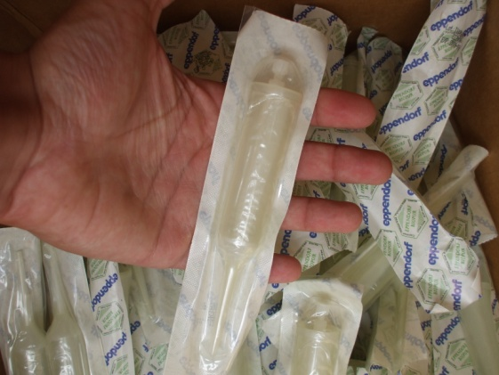
- About 1,004 New small pipet tips

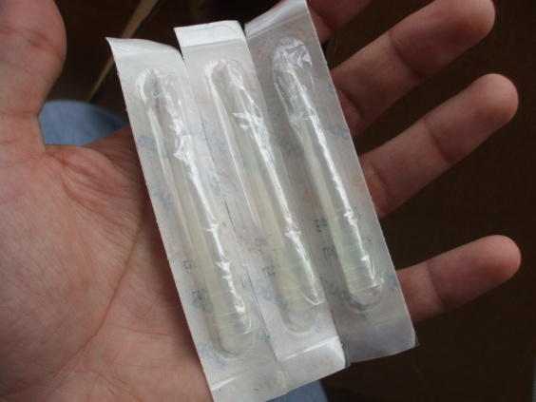
- Bags of well over 100 used small pipet tips (autoclavable?)
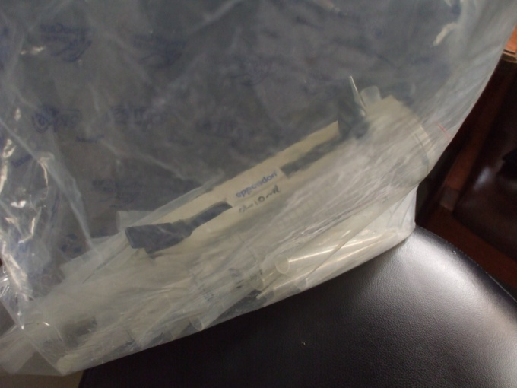
- 8 glass 5ml pipets
- 1 Starch Indicator Solution (30ml)
- Flor-Bart tests
  - 9 Expired 2009
  - 6 will expire June 2011
  - 2, Exp. Unknown because outside of box
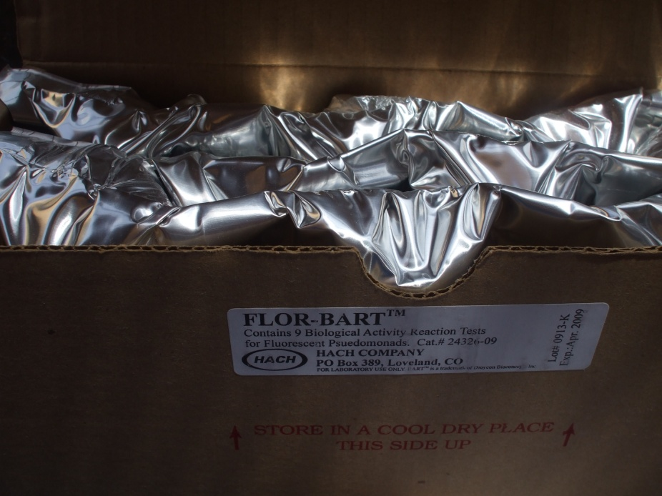
- E. Coli Positive Fluorescent Standard
  - 1 Exp. 2005
  - 1 Exp. 2009
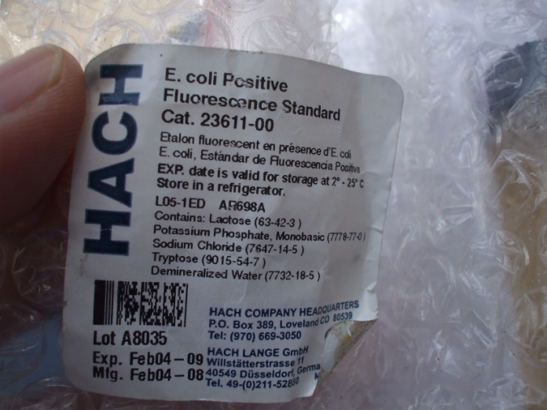
- 1 Nitrification Inhibitor Formula, Exp. Feb. 2010
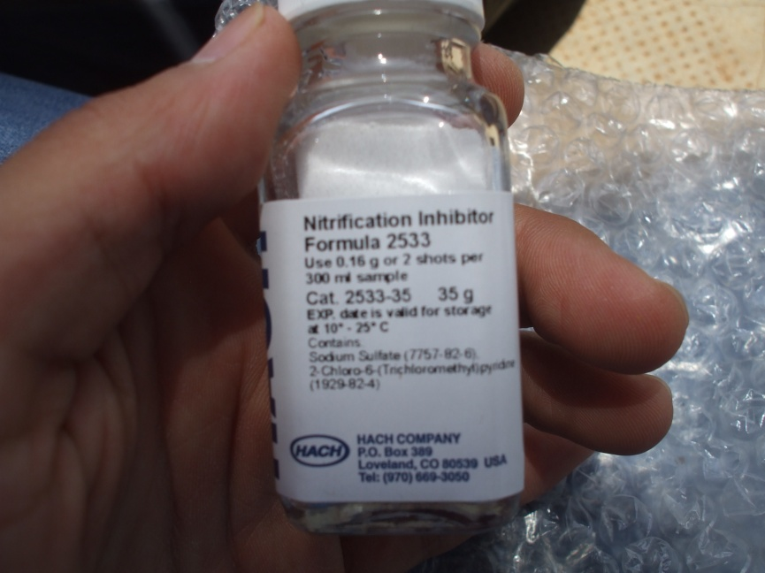
- About 35-45 microscope glass slides (many broken and dirty)
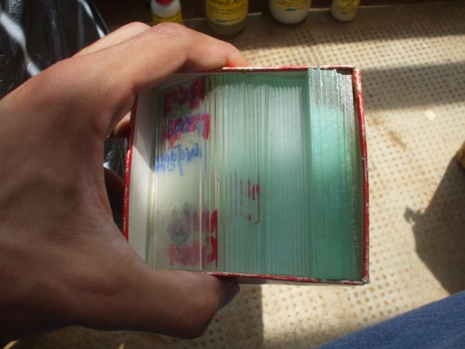
- 251 New glass vials with white caps (20ml)
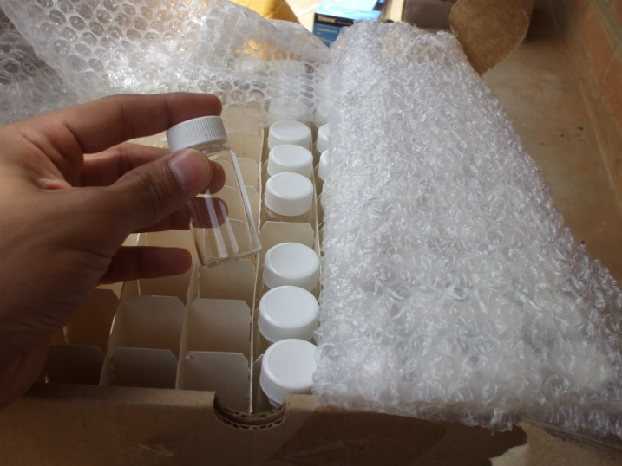
- 22 New “Wheaton 411” Glass Beakers with glass lids
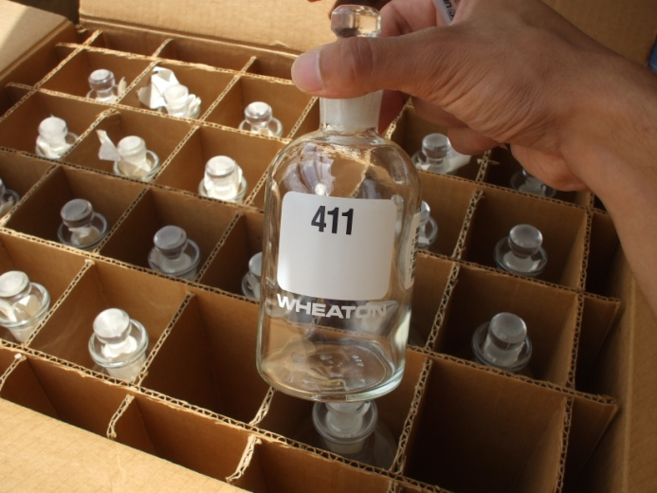
- 25 Unused Yellow Inoculating Loops
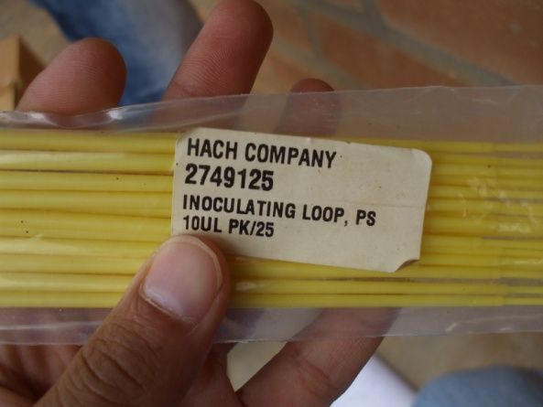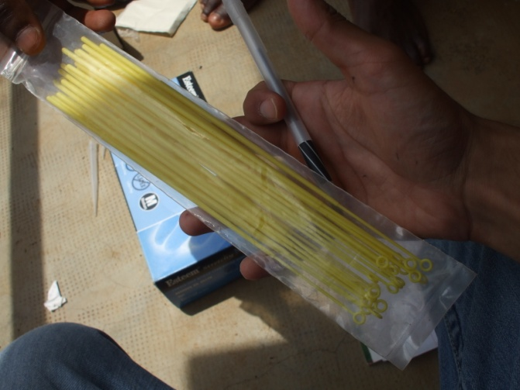
- 8 New Pyrex 25ml graduated cylinders with 8 red plastic bases and white neck rings
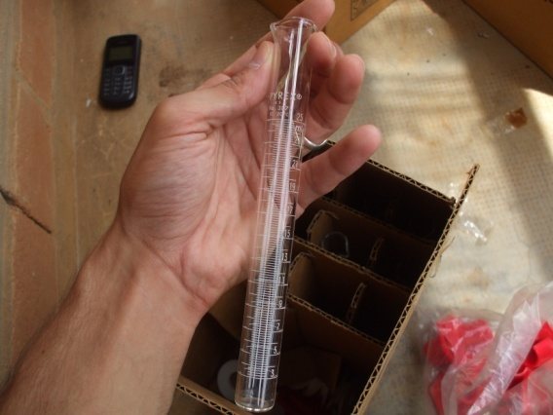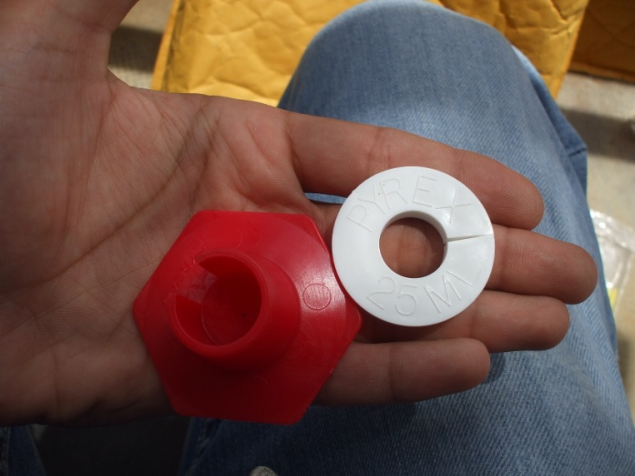
- 6 New 100ml beakers
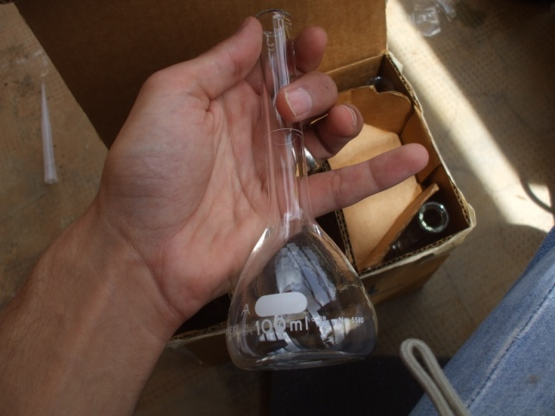
- 5 UV lamps (none currently working, maybe because of bulb or lamp itself) [NOTE: How do we dispose of used bulbs that contain mercury?]
  - 2, 115V (possibly broken due to voltage)
  - 1, 230V
  - 2, Smaller size (most likely not working because of old bulbs)
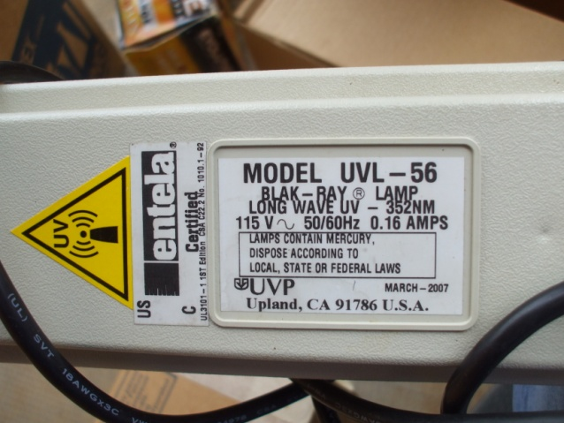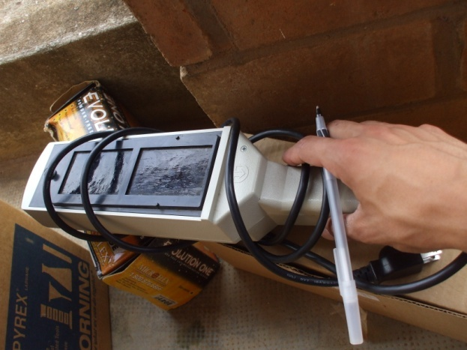
- 7 Blacklight bulbs for UV lamps
  - 2 new (larger size)
  - 3 used (larger size, maybe unusable)
  - 2 used (smaller size, probably unusable)
- The following 4 items seem to be remnants of a water test kit
  - 1 Chloride Rgt #1
  - 1 Chloride #2
  - 1 Mixed Acid
  - 1 Sulfuric Acid
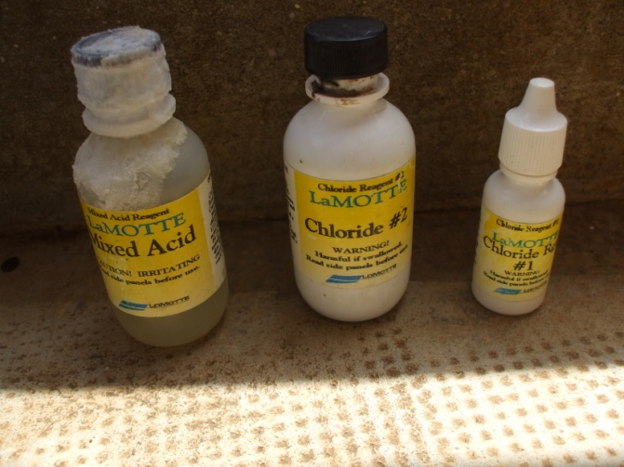
- 1 “Biplatrix” (plaster gauze?, filter?)
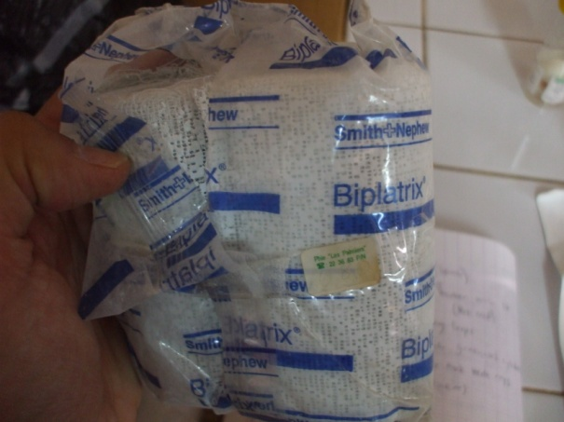
- 1, 50 pack of BOD Nutrient Buffer Pillows, Exp. Feb 2010 (A few may have been used)
- 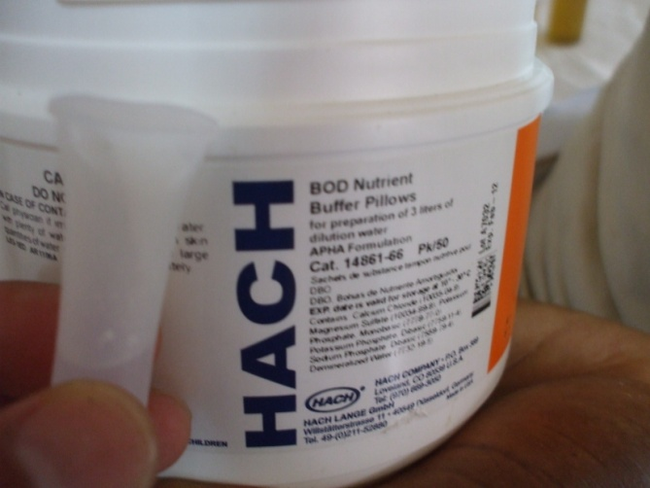
- 1 “Walgreens” Hydrogen Peroxide
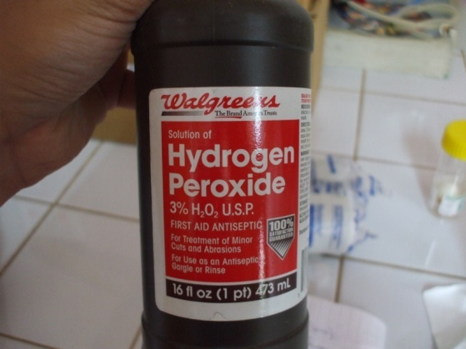
- 1 Laurel Tryptose Mug Solution, Exp Jan. 2010 (There are many others as well that have been used and most expired in 2007)
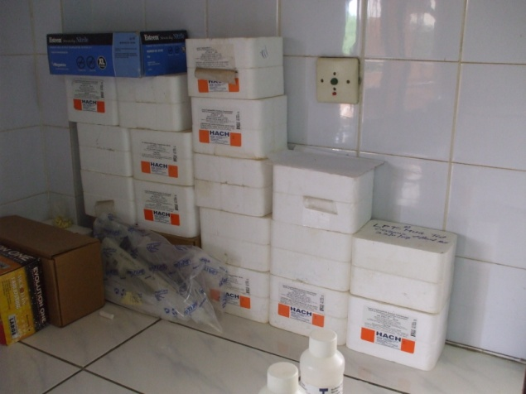
- 1 New bottle of Sulfuric Acid 1:1 (30ml)
- 1 New bottle of Sulfuric Acid 0.5N (15ml)
- 1 New bottle of Ammonia Nitrogen Reagent #2 (30ml)
- About 10 Plastic graduated cylinders
  - 2, 500ml
  - 1, 250ml
  - 1, 1000ml
  - 2, 100ml
  - 2, 50ml
  - 1, 25ml
  - 1, 10ml
- About 10 Gonzaga water bottles (1 Liter)
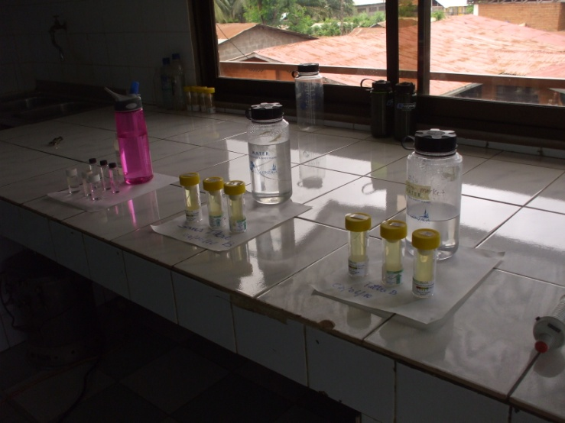
- About 70 empty glass bottles
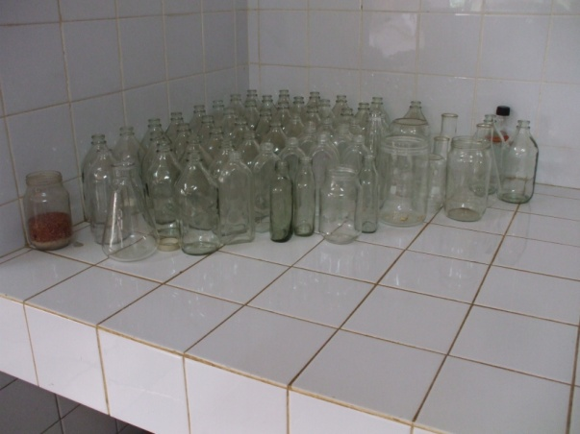
- About 200 glass bottles with mushroom materials inside
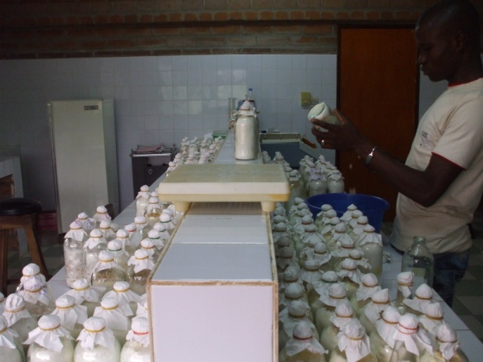
- 1 Bacto, Malt extract powder Bacto
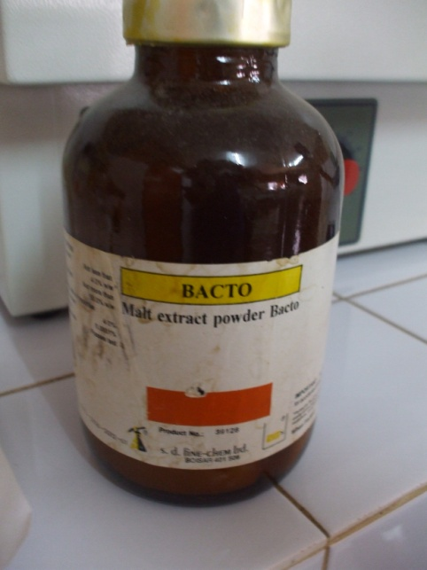
- 2 portable incubators (1 working, 1 supposedly broken)
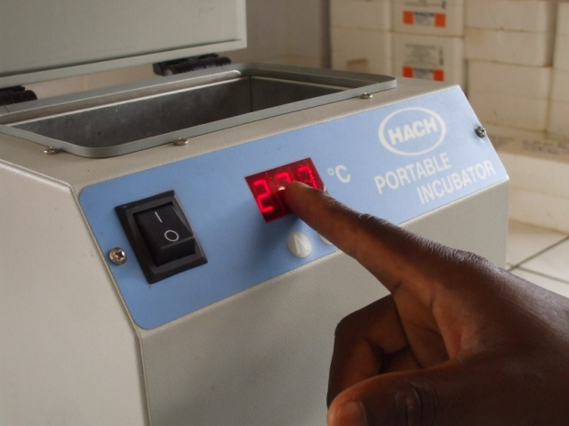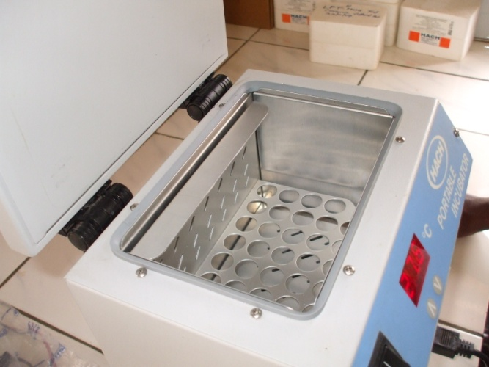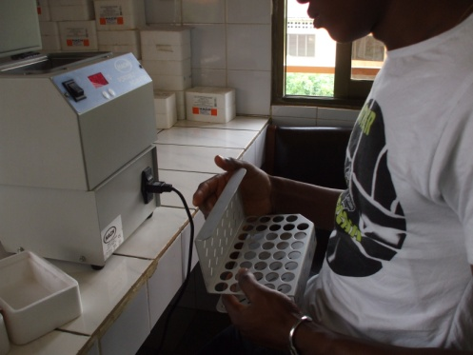
- 1 Spectrophotometer (“DR/3000”, Never used here, no one has read the instructions yet)
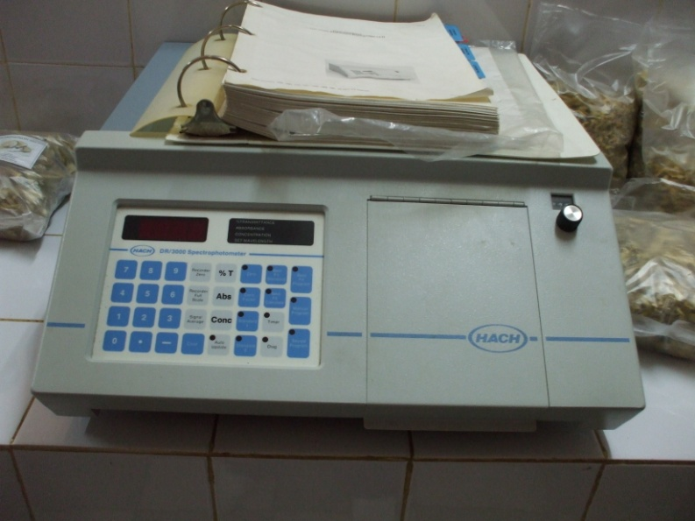
- 1 Arsenic Test Kit (Supposedly not needed in these areas, so it is not used often or perhaps at all)
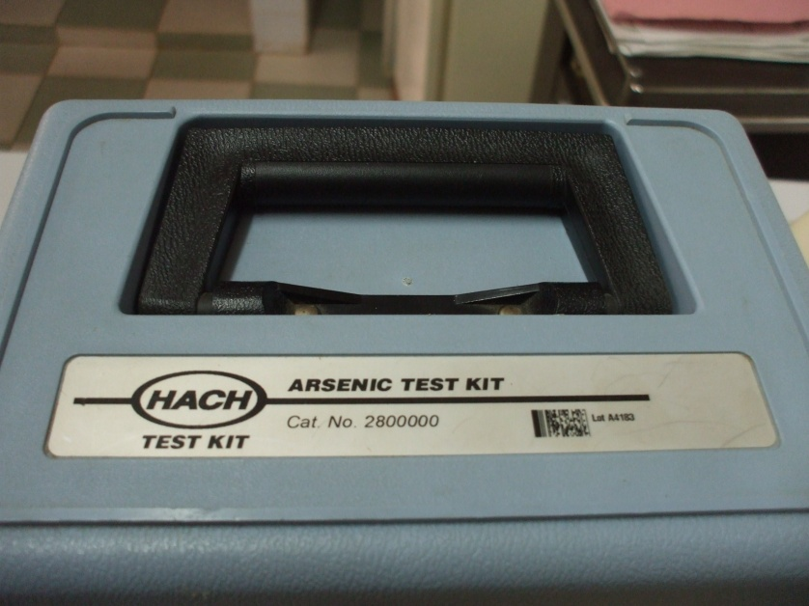
- 1 Pathoscreen Field Test Kit
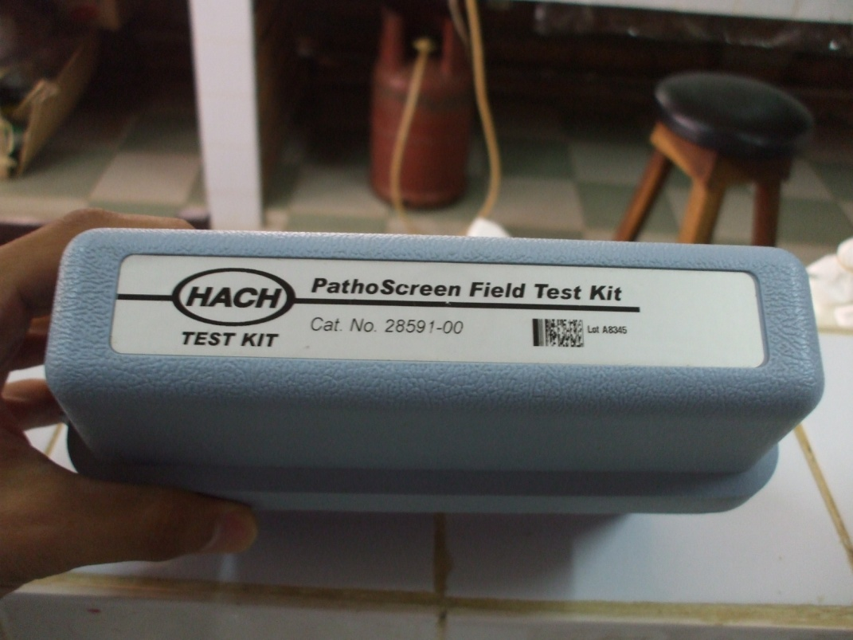
- 1 Scale (not working)
- 2 Heat Plate and Stirrer (no stirring pellets)
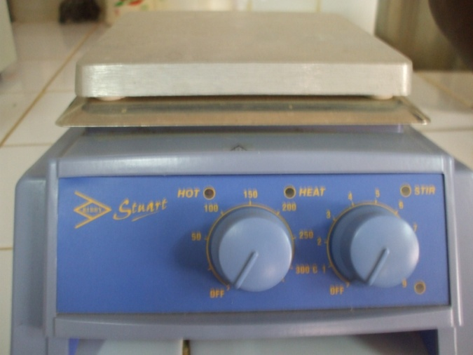
- Pathoscreen Medium MPN Pillows
  - About 215 Exp. Feb. 2008
  - 33 Exp. Jan. 2011
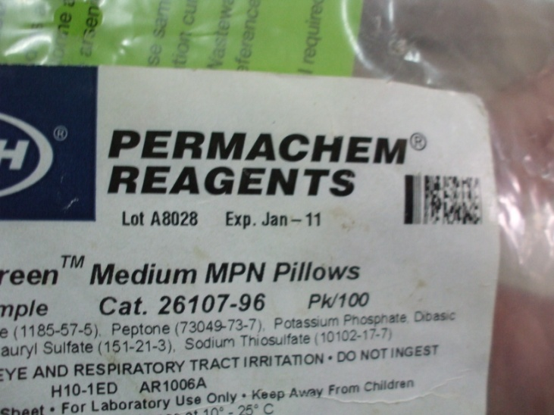
- 3 large cardboard boxes of vegetable seed packets (hundreds of packets)
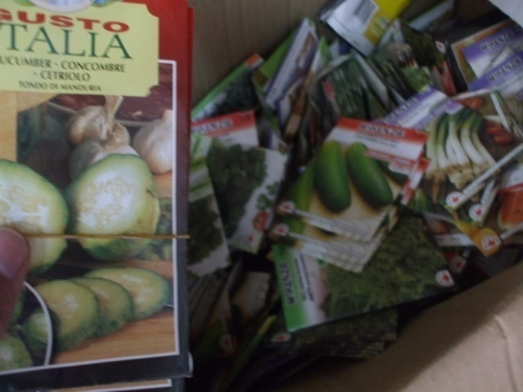
- 1 Dissolved Oxygen Meter (Not being used because previously thought to be broken, but turns on with 4 AA batteries)
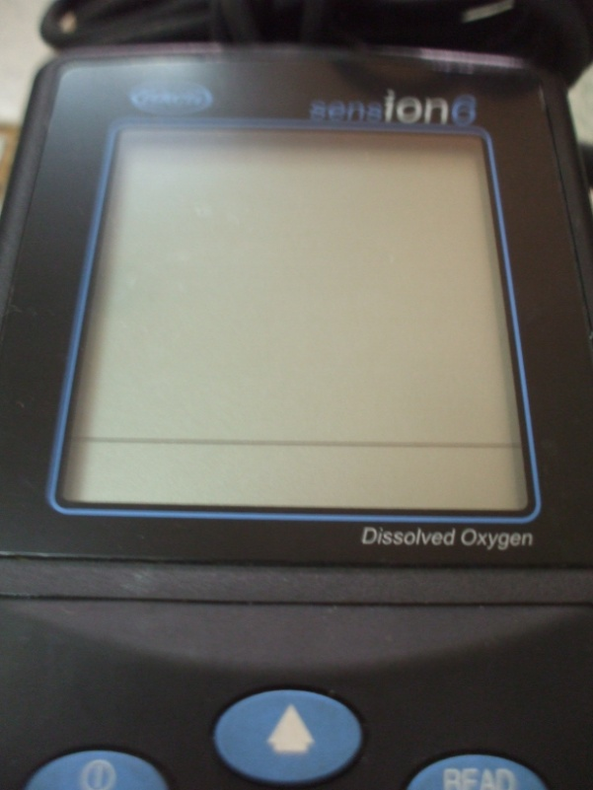
  - 3 probes
  - 1 Black Calibration and Storage Chamber
  - 1 Black Funnel?

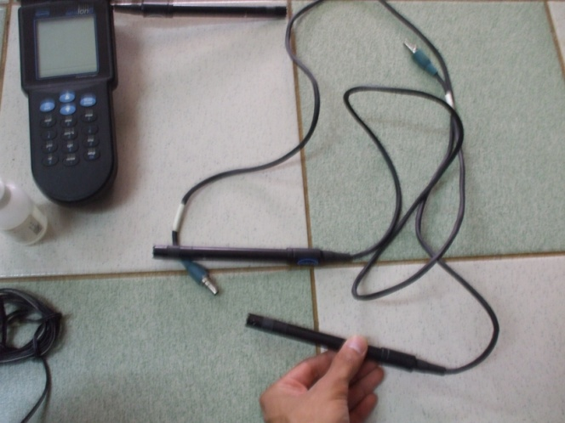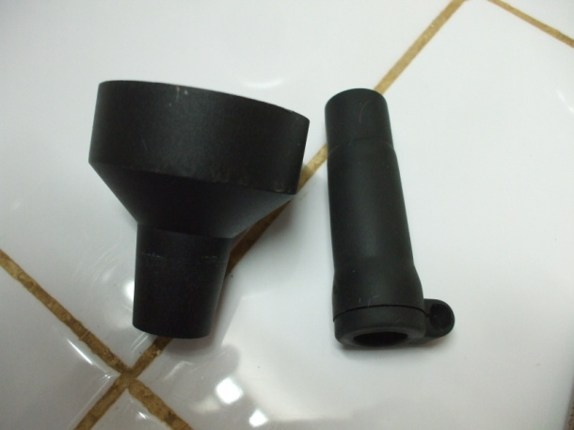
  - 1 Charger with VGA computer port (charger may be broken due to voltage difference)
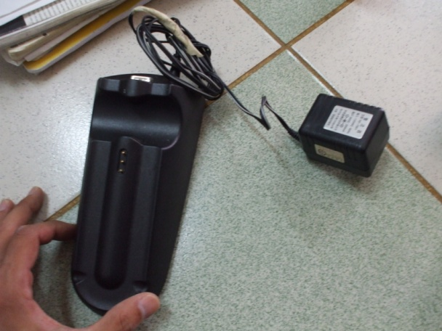
- 1 Dissolved Oxygen Electrode Filling Solution, Exp, 2006 (50ml, but half full)
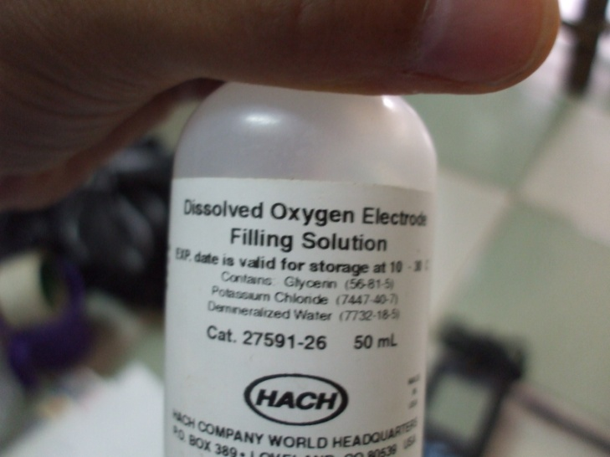
- 2 large incubators, about 2 foot height x 3 foot width x 2 foot depth
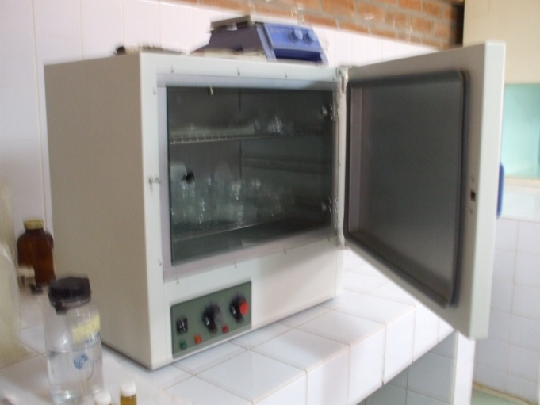
- Hundreds of plastic bags
- 8 Petri Dishes
- 2 autoclaves
  - 1 working
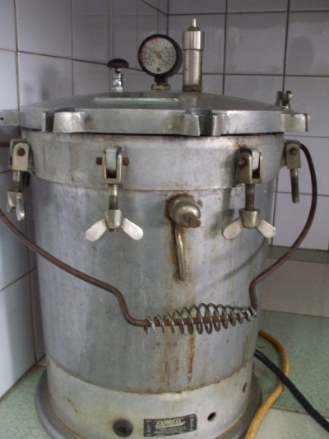
  - 1, Has not been used and no one knows how, but when plugged in turns on and seems to be fine; parts may be missing however.
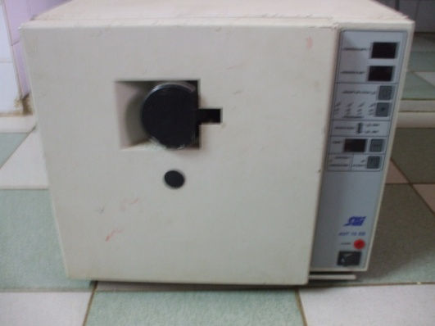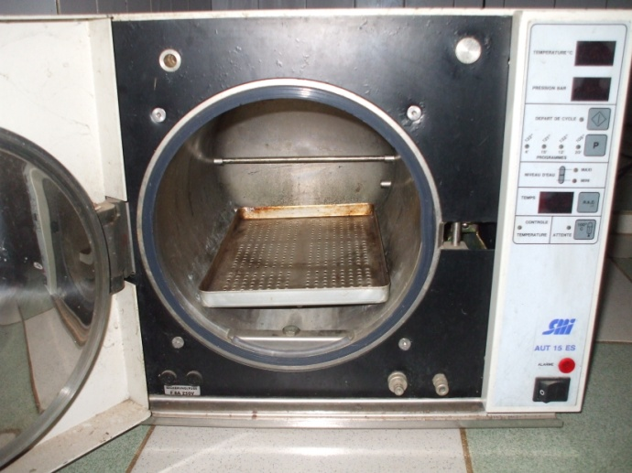
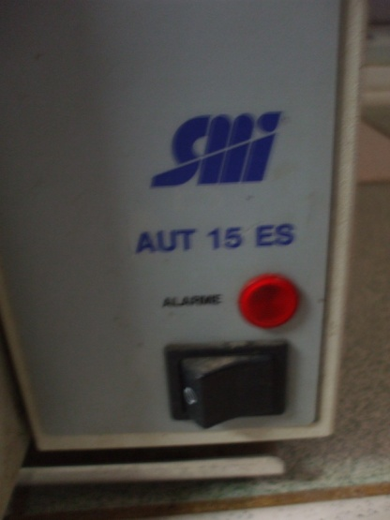
- 1 working Eppendorf Pipet, Several not working
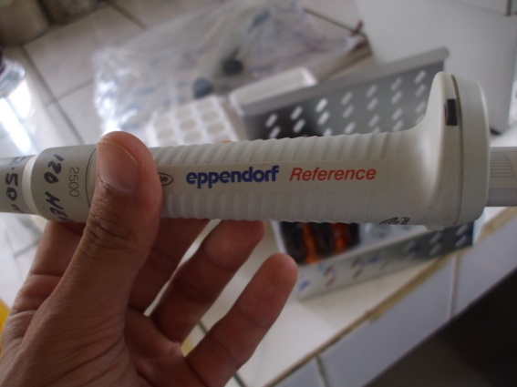
- 1 Refrigerator
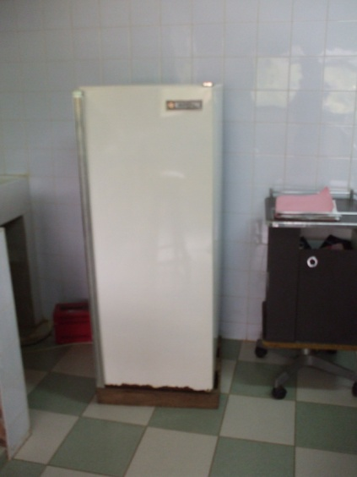
- 2 Fume hoods?
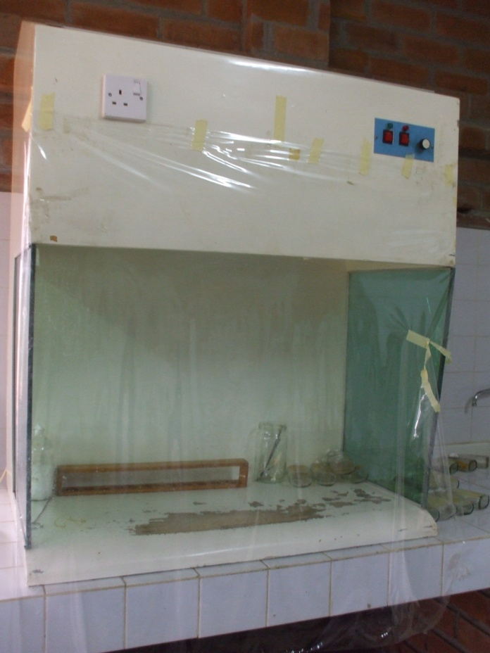
- 2 Microscopes
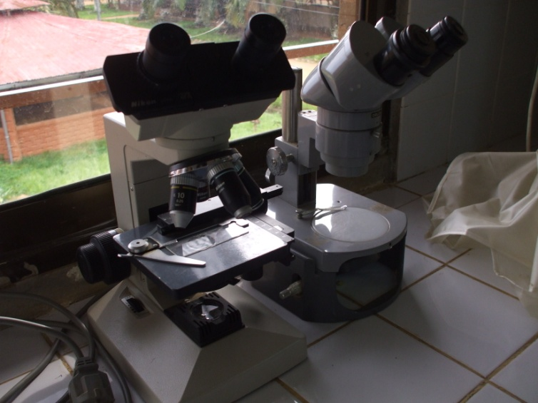
- 1 Bunsen Burner?
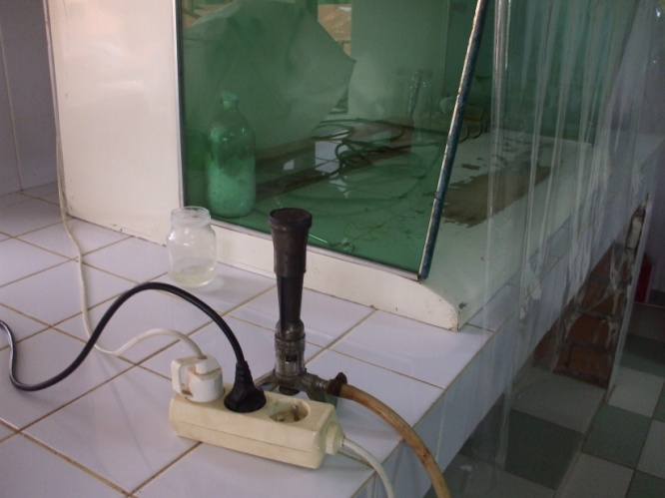
- 1 Wilson
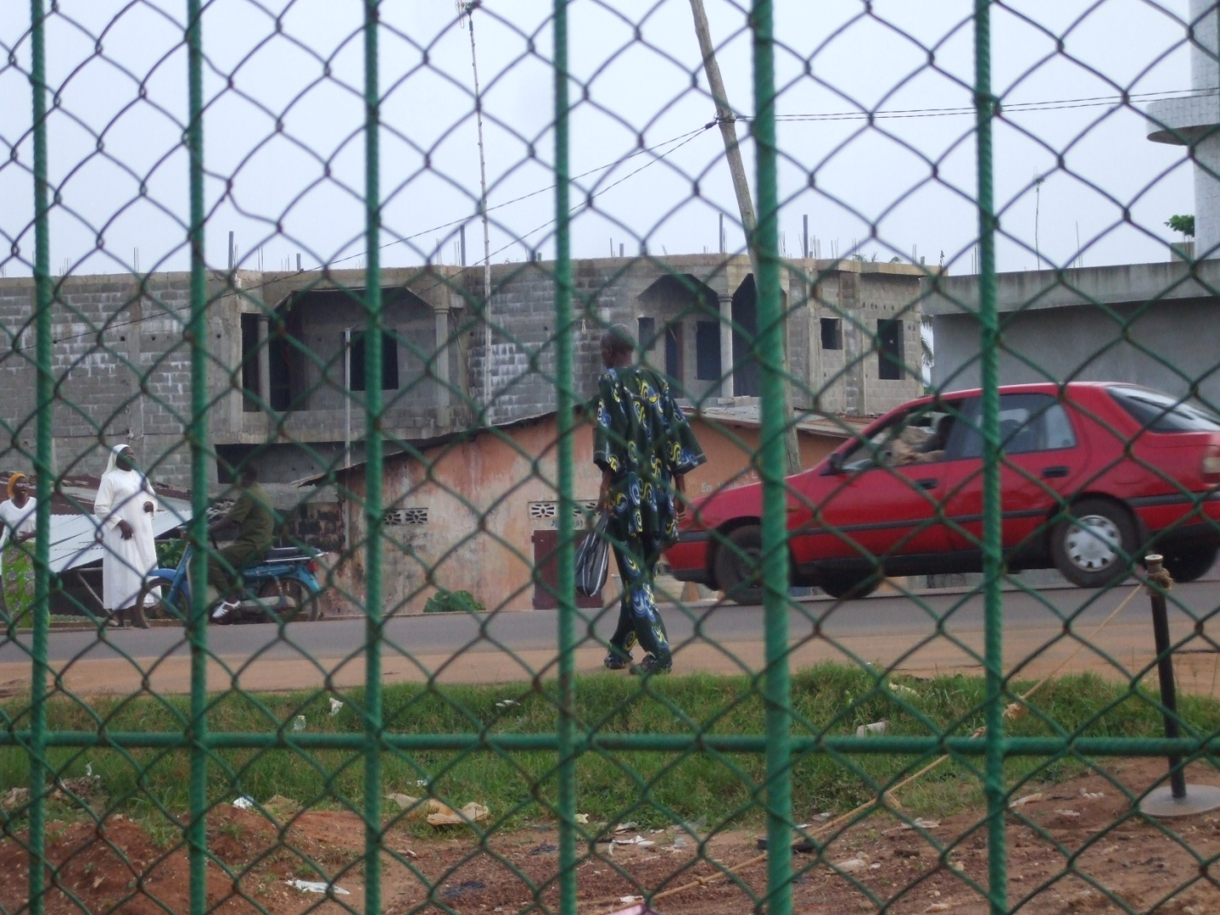
- 1 Christopher
